Artificial Intelligence - Overview

What is Artificial Intelligence?

Artificial Intelligence is a way of making a computer, a computer-controlled robot, or a software think intelligently, in the similar manner the intelligent humans think.
AI is accomplished by studying how human brain thinks, and how humans learn, decide, and work while trying to solve a problem, and then using the outcomes of this study as a basis of developing intelligent software and systems.
The term artificial intelligence was first coined decades ago in the year 1956 by John Mctarty at the Dartmouth conference. He defined artificial intelligence as the science and engineering of making intelligent machines.
Many AI applications, are not perceived as AI because we often tend to think of artificial as robots doing our daily chores. But the truth is artificial intelligence has found its way into our daily lives. It has become so general that we don’t realize we use it all the time. For instance Google is able to give you accurate search results. Facebook feed always gives you content based on your interest. This is because of the application of artificial intelligence.

Philosophy of AI
While exploiting the power of the computer systems, the curiosity of human, lead him to wonder, “Can a machine think and behave like humans do?”
Thus, the development of AI started with the intention of creating similar intelligence in machines that we find and regard high in humans.

Why Artificial Intelligence?
Before Learning about Artificial Intelligence, we should know that what is the importance of AI and why should we learn it. Following are some main reasons to learn about AI:
- With the help of AI, you can create such software or devices which can solve real-world problems very easily and with accuracy such as health issues, marketing, traffic issues, etc.
- With the help of AI, you can create your personal virtual Assistant, such as Cortana, Google Assistant, Siri, etc.
- With the help of AI, you can build such Robots which can work in an environment where survival of humans can be at risk. Eg: spirit and curiosity and Vikram.
- AI opens a path for other new technologies, new devices, and new Opportunities.

Goals of AI

- To Create Expert Systems − The systems which exhibit intelligent behavior, learn, demonstrate, explain, and advice its users.
- To Implement Human Intelligence in Machines − Creating systems that understand, think, learn, and behave like humans.

What Contributes to AI?
Artificial intelligence is a science and technology based on disciplines such as
- Computer Science,
- Biology,
- Psychology,
- Linguistics,
- Mathematics, and
- Engineering

The major thrust of AI: A major thrust of AI is in the development of computer functions associated with human intelligence, such as
- reasoning,
- learning, and
- problem solving.
Out of the following areas, one or multiple areas can contribute to build an intelligent system.

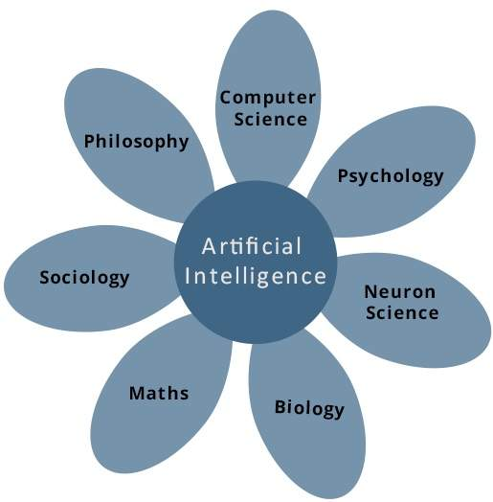

Advantages of Artificial Intelligence
Following are some main advantages of Artificial Intelligence:
- High Accuracy with less errors: AI machines or systems are prone to less errors and high accuracy as it takes decisions as per pre-experience or information.
- High-Speed: AI systems can be of very high-speed and fast-decision making, because of that AI systems can beat a chess champion in the Chess game.
- High reliability: AI machines are highly reliable and can perform the same action multiple times with high accuracy.
- Useful for risky areas: AI machines can be helpful in situations such as defusing a bomb, exploring the ocean floor, where to employ a human can be risky.
- Digital Assistant: AI can be very useful to provide digital assistant to the users such as AI technology is currently used by various E-commerce websites to show the products as per customer requirement.
- Useful as a public utility: AI can be very useful for public utilities such as a self-driving car which can make our journey safer and hassle-free, facial recognition for security purpose, Natural language processing to communicate with the human in human-language, etc.

Disadvantages of Artificial Intelligence
Every technology has some disadvantages, and the same goes for Artificial intelligence. Being so advantageous technology still, it has some disadvantages which we need to keep in our mind while creating an AI system. Following are the disadvantages of AI:
High Cost: The hardware and software requirement of AI is very costly as it requires lots of maintenance to meet current world requirements.
Can't think out of the box: Even though we are making smarter machines with AI, but still they cannot work out of the box, as the robot will only do that work for which they are trained, or programmed.
No feelings and emotions: AI machines can be an outstanding performer, but still it does not have the feeling so it cannot make any kind of emotional attachment with human, and may sometime be harmful for users if the proper care is not taken.
Increase dependency on machines: With the increment of technology, people are getting more dependent on devices and hence they are losing their mental capabilities.
No Original Creativity: As humans are so creative and can imagine some new ideas but still AI machines cannot beat this power of human intelligence and cannot be creative and imaginative.

Applications of AI
Artificial Intelligence has various applications in today's society. It is becoming essential for today's time because it can solve complex problems with an efficient way in multiple industries, such as Healthcare, entertainment, finance, education, etc. AI is making our daily life more comfortable and fast.
Following are some sectors which have the application of Artificial Intelligence:
- Gaming − AI plays crucial role in strategic games such as chess, poker, tic-tac-toe, etc., where machine can think of large number of possible positions based on heuristic knowledge.
- Natural Language Processing − It is possible to interact with the computer that understands natural language spoken by humans.
- Expert Systems − There are some applications which integrate machine, software, and special information to impart reasoning and advising. They provide explanation and advice to the users.
- Vision Systems − These systems understand, interpret, and comprehend visual input on the computer. For example,
  - A spying aeroplane takes photographs, which are used to figure out spatial information or map of the areas.
  - Doctors use clinical expert system to diagnose the patient.
  - Police use computer software that can recognize the face of criminal with the stored portrait made by forensic artist.
- Speech Recognition − Some intelligent systems are capable of hearing and comprehending the language in terms of sentences and their meanings while a human talks to it. It can handle different accents, slang words, noise in the background, change in human’s noise due to cold, etc.
- Handwriting Recognition − The handwriting recognition software reads the text written on paper by a pen or on screen by a stylus. It can recognize the shapes of the letters and convert it into editable text.
- Intelligent Robots − Robots are able to perform the tasks given by a human. They have sensors to detect physical data from the real world such as light, heat, temperature, movement, sound, bump, and pressure. They have efficient processors, multiple sensors and huge memory, to exhibit intelligence. In addition, they are capable of learning from their mistakes and they can adapt to the new environment.

- AI in Astronomy: Artificial Intelligence can be very useful to solve complex universe problems. AI technology can be helpful for understanding the universe such as how it works, origin, etc. Spotting distant planets in solar systems which is 2500 light years away.
- AI in Healthcare: In the last, five to ten years, AI becoming more advantageous for the healthcare industry and going to have a significant impact on this industry.
Healthcare Industries are applying AI to make a better and faster diagnosis than humans. AI can help doctors with diagnoses and can inform when patients are worsening so that medical help can reach to the patient before hospitalization. eg: Apple watch
IBM is one of the pioneers that has developed AI software specifically for medicine. More than 230 healthcare organizations worldwide use IBM Watson technology. In 2016, IBM Watson AI technology was able to cross-reference 20 million oncology records and correctly diagnose a rare leukaemia condition in a patient.
Google’s AI eye doctor, is another initiative taken by google where they are working with an Indian ikea chain to develop a AI system which can examine retinal scans and identify a condition called diabetic retinopathy which causes blindness.

- The google predictive search is one of the most famous AI applications. When you begin typing a search term and google makes recommendations for you to choose from. Predictive searches are based on data that Google collects about you, such as your location, your age and other personal details, By using AI the search engine attempts to guess what you might be trying to find.
- Virtual assistants: Virtual assistants like Siri, Alexa, and Cortana are examples of artificial intelligence. A newly released google virtual assistant called google duplex can respond to calls and book appointments for you, it adds a human touch.
- AI in Finance: AI and finance industries are the best matches for each other. The finance industry is implementing automation, chatbot, adaptive intelligence, algorithm trading, and machine learning into financial processes.
In the finance sector JP Morgan’s G’s contract intelligent platform uses artificial intelligence, machine learning and image recognition software to analze legal documents and extract important data points and clauses in a matter of seconds. Manually reviewing 12000 agreements takes over 36000 hours but AI was able to do this in a matter of seconds.
- AI in Data Security: The security of data is crucial for every company and cyber-attacks are growing very rapidly in the digital world. AI can be used to make your data more safe and secure. Some examples such as AEG bot, AI2 Platform,are used to determine software bug and cyber-attacks in a better way.
- AI in Social Media: Social Media sites such as Facebook, Twitter, and Snapchat contain billions of user profiles, which need to be stored and managed in a very efficient way. AI can organize and manage massive amounts of data. AI can analyze lots of data to identify the latest trends, hashtag, and requirement of different users.
In social media platforms like facebook, artificial intelligence is used for face verification where in machine learning and deep learning concepts are used to detect facial features and tag your friends.
Twitter’s AI is being used to identify hate speech and terroristic languages in tweets. It makes use of machine learning, deep learning, and natural language processing to filter out offensive content. The company discovered and banned three hundred thousand terrorist linked accounts, 95% of which were found by non human artificially intelligent machines.
- AI in Travel & Transport: AI is becoming highly demanding for travel industries. AI is capable of doing various travel related works such as from making travel arrangement to suggesting the hotels, flights, and best routes to the customers. Travel industries are using AI-powered chatbots which can make human-like interaction with customers for better and fast response.
- AI in Automotive Industry: Some Automotive industries are using AI to provide virtual assistant to their user for better performance. Such as Tesla has introduced TeslaBot, an intelligent virtual assistant.
Various Industries are currently working for developing self-driven cars which can make your journey more safe and secure.
Self Driving Cars: AI implements computer vision, image detection and deep learning to build cars, that can automatically detect objects and drive around without human intervention. Elon Musk talks about how AI is implemented in Tesla’s self driving cars and auto-pilot features. Their Robo taxi version one that can ferry passengers without anyone behind the wheel.

- AI in Robotics: Artificial Intelligence has a remarkable role in Robotics. Usually, general robots are programmed such that they can perform some repetitive task, but with the help of AI, we can create intelligent robots which can perform tasks with their own experiences without pre-programmed.
Humanoid Robots are best examples for AI in robotics, recently the intelligent Humanoid robot named as Erica and Sophia has been developed which can talk and behave like humans.
- AI in Entertainment: We are currently using some AI based applications in our daily life with some entertainment services such as Netflix or Amazon. With the help of ML/AI algorithms, these services show the recommendations for programs or shows.
- AI in Agriculture: Agriculture is an area which requires various resources, labor, money, and time for best result. Now a day's agriculture is becoming digital, and AI is emerging in this field. Agriculture is applying AI as agriculture robotics, solid and crop monitoring, predictive analysis. AI in agriculture can be very helpful for farmers.
- AI in E-commerce: AI is providing a competitive edge to the e-commerce industry, and it is becoming more demanding in the e-commerce business. AI is helping shoppers to discover associated products with recommended size, color, or even brand.
- AI in education: AI can automate grading so that the tutor can have more time to teach. AI chatbot can communicate with students as a teaching assistant.
AI in the future can be work as a personal virtual tutor for students, which will be accessible easily at any time and any place.
- Literature: composing sonets and poems

Common Misconceptions:

People often tend to think that
- artificial intelligence
- machine earning and
- deep learning
are the same since they have common applications.
For example Siri is an application of AI, machine learning and deep learning. So how are these technologies related?
Artificial intelligence is the science of getting machines to mimic the behavior of humans.
Machine learning is a subset of AI that focuses on getting machines to make decisions by feeding them data.
Deep learning is a subset of machine learning that uses the concept of neural networks to solve complex problems.
Therefore artificial intelligence, machine learning and deep learning are interconnected fields.
Machine learning and deep learning aids artificial intelligence by providing a set of algorithms and neural networks to solve data driven problems.
But AI is not restricted to only machine learning and deep learning. It covers a vast domain of fields including
- Natural Language Processing,
- Object Detection,
- Computer Vision,
- robotics,
- expert systems, and so on.

Types of Artificial Intelligence:
Artificial Intelligence can be divided in various types, there are mainly two types of main categorization which are based on capabilities and based on functionally of AI. Following is flow diagram which explain the types of AI.
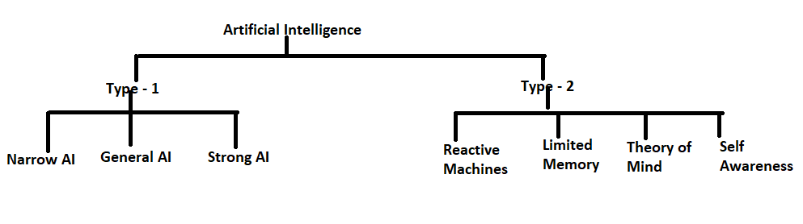

AI type-1: Based on Capabilities

1. Weak AI or Narrow AI:
- Narrow AI is a type of AI which is able to perform a dedicated task with intelligence. The most common and currently available AI is Narrow AI in the world of Artificial Intelligence.
- Narrow AI cannot perform beyond its field or limitations, as it is only trained for one specific task. Hence it is also termed as weak AI. Narrow AI can fail in unpredictable ways if it goes beyond its limits.
- Apple Siri is a good example of Narrow AI, but it operates with a limited pre-defined range of functions.
- IBM's Watson supercomputer also comes under Narrow AI, as it uses an Expert system approach combined with Machine learning and natural language processing.
- Some Examples of Narrow AI are playing chess, purchasing suggestions on e-commerce site, self-driving cars, speech recognition, and image recognition.

2. General AI:
- General AI is a type of intelligence which could perform any intellectual task with efficiency like a human.
- The idea behind the general AI to make such a system which could be smarter and think like a human by its own.
- Currently, there is no such system exist which could come under general AI and can perform any task as perfect as a human.
- The worldwide researchers are now focused on developing machines with General AI.
- As systems with general AI are still under research, and it will take lots of efforts and time to develop such systems.

3. Super AI:
- Super AI is a level of Intelligence of Systems at which machines could surpass human intelligence, and can perform any task better than human with cognitive properties. It is an outcome of general AI.
- Some key characteristics of strong AI include capability include the ability to think, to reason, solve the puzzle, make judgments, plan, learn, and communicate by its own.
- Super AI is still a hypothetical concept of Artificial Intelligence. Development of such systems in real is still world changing task.

Narrow AI – Dedicated for one task
General AI – Performs like human
Super AI – Intelligent than human

Artificial Intelligence type-2: Based on functionality

1. Reactive Machines
- Purely reactive machines are the most basic types of Artificial Intelligence.
- Such AI systems do not store memories or past experiences for future actions.
- These machines only focus on current scenarios and react on it as per possible best action.
- IBM's Deep Blue system is an example of reactive machines.
- Google's AlphaGo is also an example of reactive machines.

2. Limited Memory
- Limited memory machines can store past experiences or some data for a short period of time.
- These machines can use stored data for a limited time period only.
- Self-driving cars are one of the best examples of Limited Memory systems. These cars can store recent speed of nearby cars, the distance of other cars, speed limit, and other information to navigate the road.

3. Theory of Mind
- Theory of Mind AI should understand the human emotions, people, beliefs, and be able to interact socially like humans.
- This type of AI machines are still not developed, but researchers are making lots of efforts and improvement for developing such AI machines.

4. Self-Awareness
- Self-awareness AI is the future of Artificial Intelligence. These machines will be super intelligent, and will have their own consciousness, sentiments, and self-awareness.
- These machines will be smarter than human mind.
- Self-Awareness AI does not exist in reality still and it is a hypothetical concept.

Since the emergence of AI in the 1950s, we have seen an exponential growth in its potential. AI cover domains such as machine learning, deep learning, neural networks, natural language processing, knowledge base, expert systems, and so on. It has also made its way into computer vision and image processing.

